Test Case: tc003_SPX_Dev5_Crear_Requisicion_Spot_Tipo_Cobro_CC_Urgent
Step 1 - Enter username and password and click to button Enter : Credentials Entered
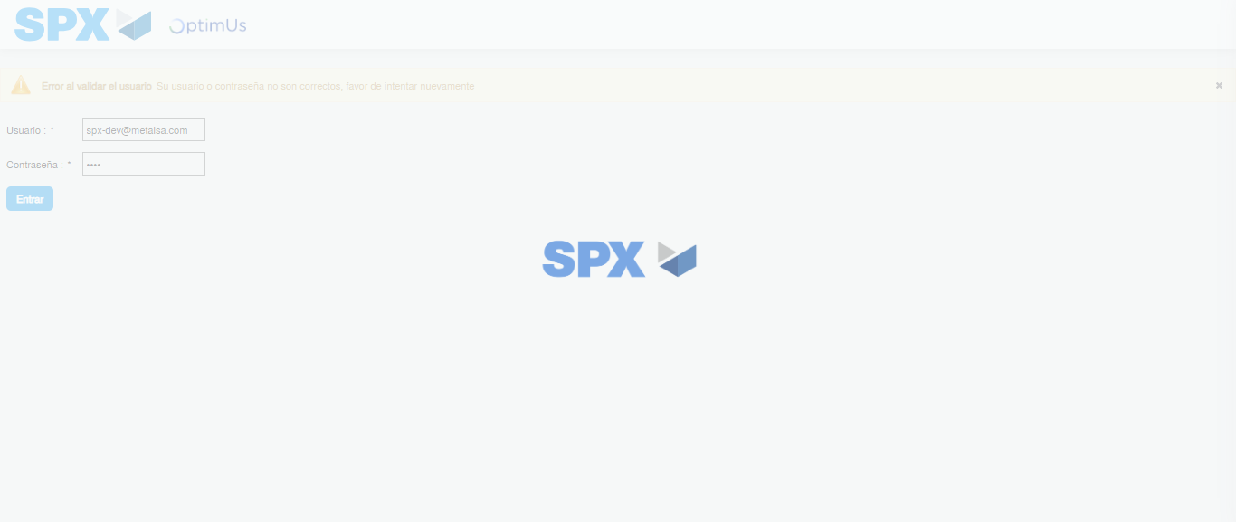Image file-name: QC_Testing-tc003_SPX_Dev5_Crear_Requisicion_Spot_Tipo_Cobro_CC_Urgent-1785960144824

Step 2 - Select to UEN and Access to Spot Buy Requisitions : UEN Correctly selected and Correct access
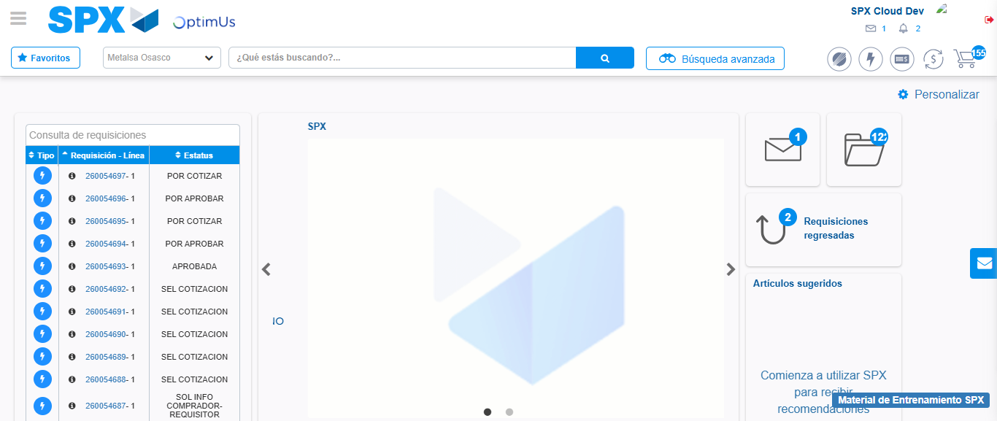Image file-name: QC_Testing-tc003_SPX_Dev5_Crear_Requisicion_Spot_Tipo_Cobro_CC_Urgent-1785960201546

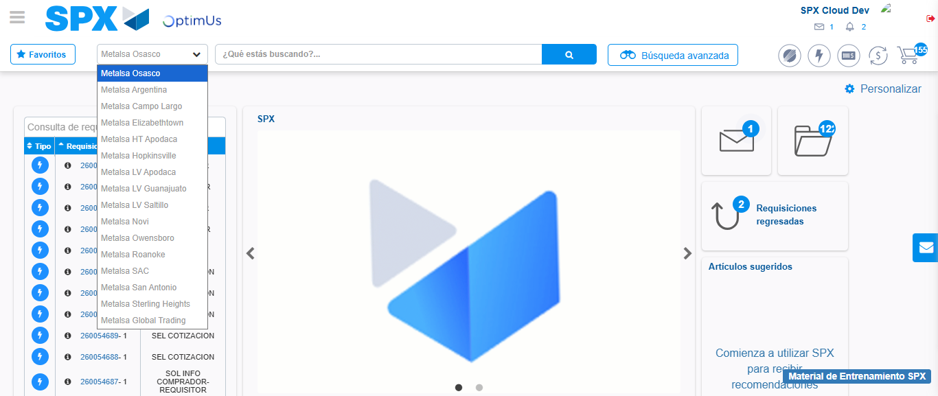Image file-name: QC_Testing-tc003_SPX_Dev5_Crear_Requisicion_Spot_Tipo_Cobro_CC_Urgent-1785960204321

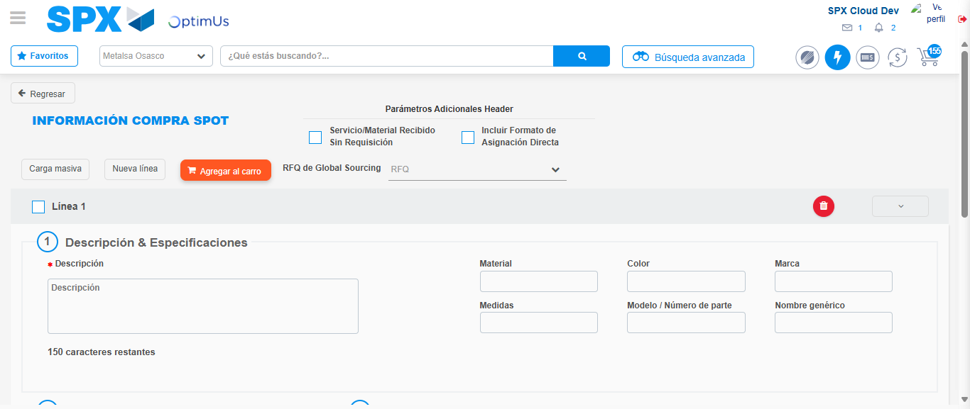Image file-name: QC_Testing-tc003_SPX_Dev5_Crear_Requisicion_Spot_Tipo_Cobro_CC_Urgent-1785960217230

Step 3 - Data Capture Spot Buy Requisition: Data captured correctly
Image file-name: QC_Testing-tc003_SPX_Dev5_Crear_Requisicion_Spot_Tipo_Cobro_CC_Urgent-1785960217540

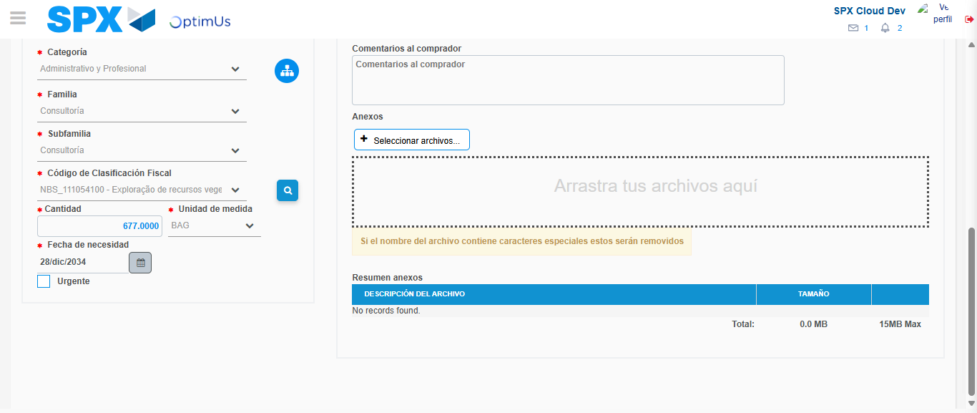Image file-name: QC_Testing-tc003_SPX_Dev5_Crear_Requisicion_Spot_Tipo_Cobro_CC_Urgent-1785960235761

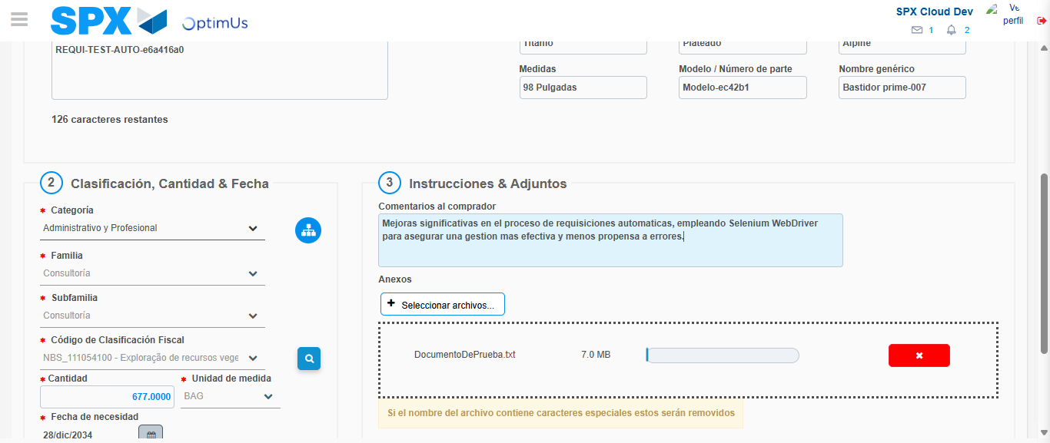Image file-name: QC_Testing-tc003_SPX_Dev5_Crear_Requisicion_Spot_Tipo_Cobro_CC_Urgent-1785960236664

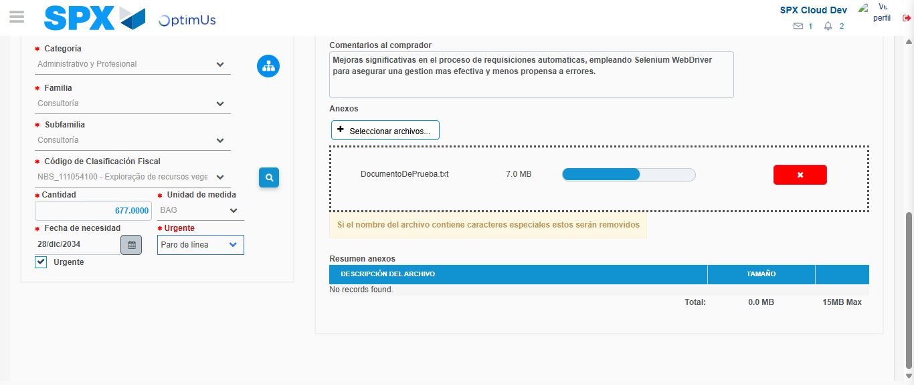Image file-name: QC_Testing-tc003_SPX_Dev5_Crear_Requisicion_Spot_Tipo_Cobro_CC_Urgent-1785960240497

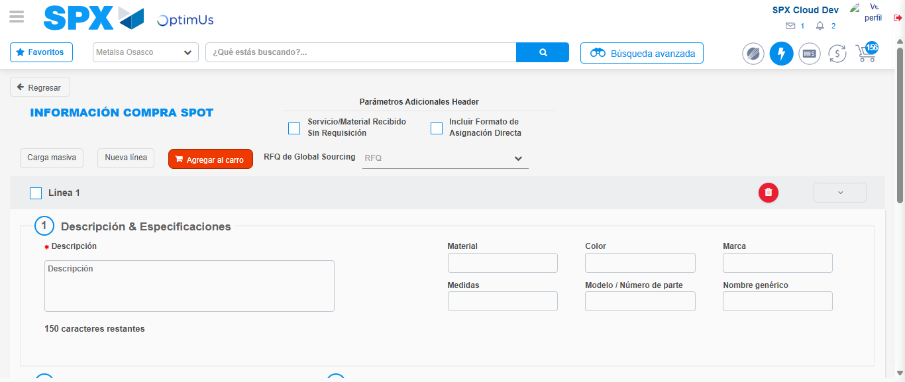Image file-name: QC_Testing-tc003_SPX_Dev5_Crear_Requisicion_Spot_Tipo_Cobro_CC_Urgent-1785960266090

Step 7 - Return to Main Page SPX : Return to Main Page SPX
Image file-name: QC_Testing-tc003_SPX_Dev5_Crear_Requisicion_Spot_Tipo_Cobro_CC_Urgent-1785960201546

Image file-name: QC_Testing-tc003_SPX_Dev5_Crear_Requisicion_Spot_Tipo_Cobro_CC_Urgent-1785960204321

Image file-name: QC_Testing-tc003_SPX_Dev5_Crear_Requisicion_Spot_Tipo_Cobro_CC_Urgent-1785960217230

Image file-name: QC_Testing-tc003_SPX_Dev5_Crear_Requisicion_Spot_Tipo_Cobro_CC_Urgent-1785960268389

Image file-name: QC_Testing-tc003_SPX_Dev5_Crear_Requisicion_Spot_Tipo_Cobro_CC_Urgent-1785960268609

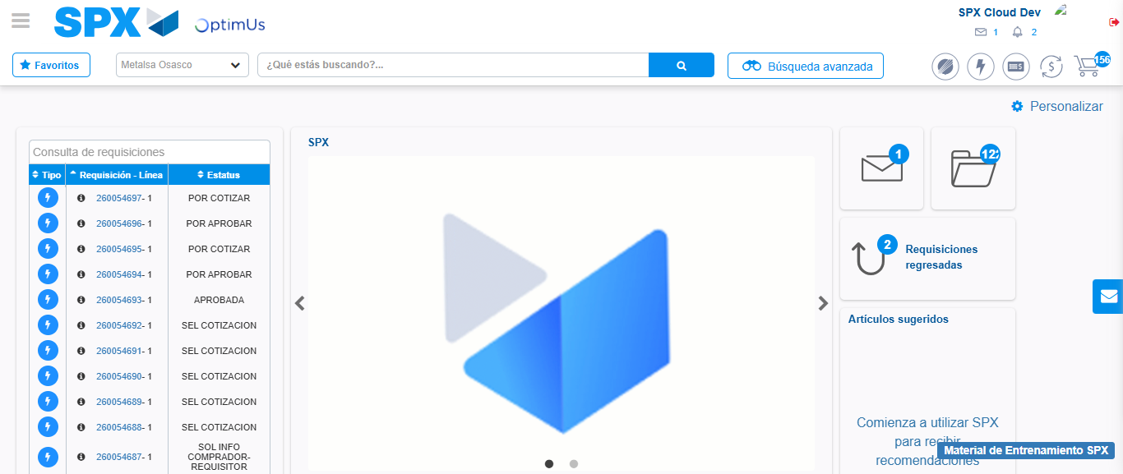Image file-name: QC_Testing-tc003_SPX_Dev5_Crear_Requisicion_Spot_Tipo_Cobro_CC_Urgent-1785960289871

Step 8 - Log Out : Log Out SPX
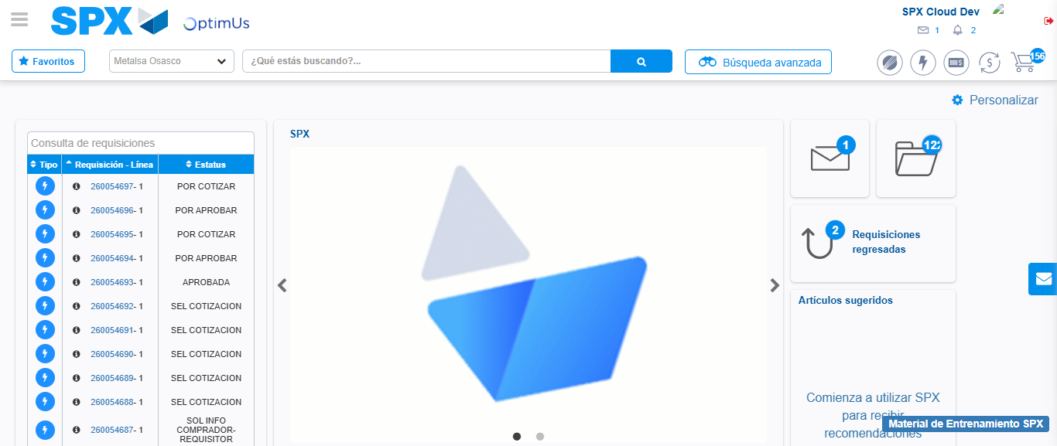Image file-name: QC_Testing-tc003_SPX_Dev5_Crear_Requisicion_Spot_Tipo_Cobro_CC_Urgent-1785960290193

